Wednesday: GitHub Pages
We've made some web pages that we can view on our personal computers. Now let's learn how we can host our sites online. There are a number of ways to do this, and GitHub offers an option that is free and one of the easiest out there. GitHub Pages lets us turn a GitHub repository into a website with a URL that we can access from any browser. Pretty neat!
In this lesson, we will walk through the steps to get a website from an existing repository hosted. I am going to use my-first-project from the previous lesson on Creating a Web Page to demonstrate. Feel free to use your version of this project, or a different project that you would like to see online. The directions will be the same, and GitHub does not limit the number of sites that you can host online.
Before we get started, let's go over a typical project structure for any website. In previous lessons, we put our images and CSS stylesheets in images and css folders. It's pretty common to organize files in this way.
So far, we have been giving our pages descriptive file names, such as my-first-website.html or my-favorite-things.html. Another convention is to name the HTML file for the main page for a website index.html. This naming convention is common practice in the industry. Additionally, many hosting services, including GitHub Pages, require this convention to display content. Let's change the name of my-first-website.html to index.html now. GitHub won't know to display it as the main page if we don't.
$ mv my-first-website.html index.html

Since we have been using Git to track our project, let’s commit the change.
$ git add .
$ git commit -m "Change name of favorite-things.html file to index.html."
$ git push origin master

One of the most important features when using Git or any other version control system is the ability to create a branch. We will go more into detail about what exactly a branch is and how it works in an upcoming lesson, but for now, you can think of it like an exact copy of the code at the point when the branch is created. Each branch exists independent of each other, so once you create a branch, any changes you make to one branch won’t affect the code in another branch. GitHub Pages looks for content to display online in a branch called gh-pages. Let's create that branch now. Run these commands in the Terminal:
$ git branch gh-pages

We used the git branch command to create a new branch called gh-pages. Again, we will go more into detail about branching in an upcoming lesson. For now, what matters is that we have a branch called gh-pages, and it is a copy of the code in the master branch. Next, we push the code to GitHub:
$ git push origin gh-pages

Notice that the last argument in this command is gh-pages, which means that we are pushing the gh-pages branch.
Once the project is pushed to GitHub, you will be able to view it online at github-username.github.io/repository-name. For example, if our GitHub username was moringa-school-student, and our repository was named hello-world, we would navigate to moringa-school-student.github.io/hello-world in the browser.
One last thing to note here. For now, if you want to continue making changes to a project, you should edit the code in the master branch, not gh-pages. Then, when you want to update the live site on github.io, delete the gh-pages branch and then create it again using the steps above.
To delete a branch, first click on the Branches tab at the top of the repository's main page:
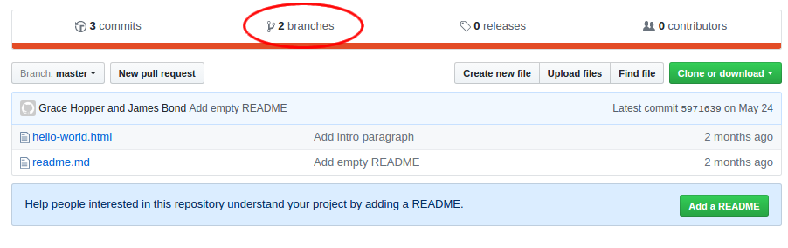
This will take you to a page where all of the repository's branches are listed. Delete a branch by clicking on the red trash can symbol in the branch's row on the right side of the page:
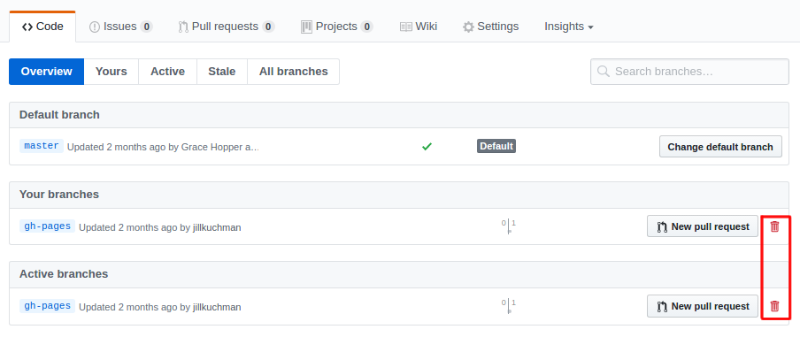

Wednesday: Practice: GitHub Pages
Goal: Walk through the process of creating and publishing to a GitHub pages page by publishing one of our previous projects.

Warm Up
Discuss the following questions with your partner:
- We need to create something called a branch to publish our content on GitHub pages. We'll learn more about branches later, but for now, what is the specific name we must call the branch in order for Github pages to work correctly?
- What is the easiest way to add new changes to a Github pages site after it's already been published?

Code

Publish to GitHub Pages
Now that you have learned how to host your web pages on GitHub Pages, go ahead and make your pet homepage display on GitHub Pages as well. Make sure that each project properly displays for you and your partner. If it isn't working, make sure you have confirmed your email address with GitHub.

Wednesday: Git Branching
So far we've learned what Git and GitHub are, how to set up a project, track changes, push code to GitHub, clone projects back down from GitHub into a local Git repository, and even publish websites on GitHub Pages.
In this lesson we'll dive deeper into Git by exploring something called branching. We were introduced to branching briefly when we learned about GitHub pages. In this lesson, we'll learn more about what it is, how it works, what benefits it offers, and how to create and maintain branches in our own projects.
To do this, we'll walk through creating an example project in the next two lessons. Together, we'll create and merge branches in this example project. Then, in an upcoming exercise you'll have the opportunity to work with branches on your own project with a partner.

Overview
In Git, branching is the act of creating multiple copies of similar code in the same repository. There are many reasons developers do this. Here are a few of the most common:
- Multiple branches allow a team of developers to work together without "stepping on each others' feet", so to speak. If a team was all working on the same files at the same time, things could get messy very quickly. Branches allow each developer their own copy of the project to work on. When part of the project is done, the team can merge multiple branches together into a completed final product.
- Branching also allows us to experiment with changes without risking our final product. We can use branching to create a copy of our code separate from our final version to experiment with new features and code. If this new code causes any bugs, we can rest assured knowing our original code is still safe!
- Branching allows us to pursue multiple options at once. Not sure which approach to a problem is preferable? With branching, you can always create multiple copies of your project, try implementing different code in each, and see which result is preferable.

Master Branch
You may be surprised to learn that you've been interacting with branches since the beginning of the course! At this point in the curriculum, you've most likely pushed several projects to GitHub already, and published at least one on GitHub Pages. Your current GitHub repositories should look something like this:
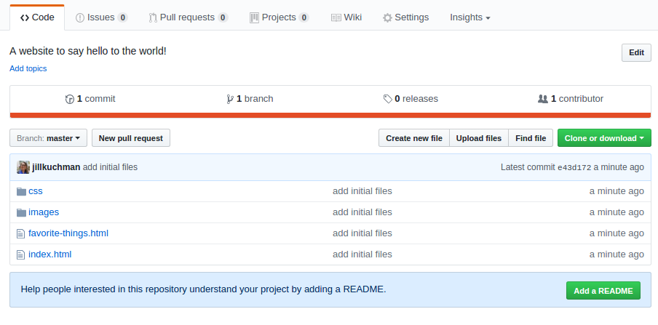
Notice the drop-down menu on the left side labeled Branch. If we click this drop-down we see it contains one entry: master (if you've published a project to GitHub pages it will also contain a branch named gh-pages).
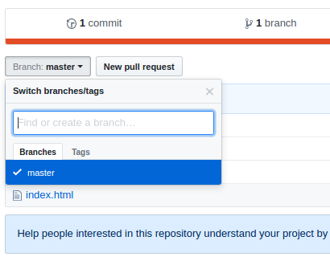
When you learned how to push a project to a remote GitHub repo yesterday, you pushed your local Git repositories to online GitHub repositories using a command like this:
$ git push origin master
The master portion of this command instructs Git to push the current master copy of your local repository to the remote repository under the nickname origin.
But what does master mean? Well, projects tracked in Git and GitHub may have multiple branches. The term "master" specifies that code should be pushed to the master branch on GitHub. Remember, we saw there was a branch named master in the dropdown menu on GitHub.
A branch is just another copy or version of the project's main code. Both Git and GitHub repositories may have multiple branches at once. There is always at least one branch in a project: master.
"Master" is the name of the default branch. If you don't create or navigate between branches in your project, you will have one branch named master, and you will be located in it by default. When you have multiple branches in a project, the master branch is like the "final draft".
Branches that are not master are often referred to as feature branches, because they allow developers to experiment with new features before integrating them into the "final draft" master branch.
Additionally, you probably published a project to GitHub pages with a command like this in a previous lesson:
$ git push origin gh-pages
Much like master, gh-pages is also a branch name. While master is responsible for containing the final product, gh-pages is responsible for publishing content to GitHub's special GitHub Pages tool.

Example Project
Let's walk through a basic example of branching together. We'll craft a small website. Then, we'll create multiple branches to experiment with different CSS styles. We'll compare the styles, choose which we like best, and integrate the favored styles into our "final draft" (that is, our master branch). You and your partner should begin following along at this time.

Project Directory
Next, let's create a new project directory in the Documents folder. Remember, whenever we start a new project we must create a new directory for it to reside in. First, we'll navigate to Documents:
$ cd Documents
Then, we'll create a new directory called branching-test-project:
$ mkdir branching-test-project
If we run $ ls we can see our new branching-test-project directory. Next, use the $ cd command to navigate to the new project folder:
$ cd branching-test-project
Remember, if you're ever unsure of your location in the command line you can run the $ pwd command.

Git Initialization
Next, we'll initialize our Git repository:
$ git init

HTML File
Next, let's create an HTML file for our website's code:
$ touch branching-website.html
We'll open our project directory in Atom:
$ atom .
And add the following code to our branching-website.html file:
branching-website.html
<!DOCTYPE html>
<html>
<head>
<title> Branching Practice Site </title>
</head>
<body>
<h1> Branching </h1>
<h2> A website to practice branching with Git. </h2>
<p> This page has been created in order to practice branching with Git and GitHub. By creating branches, we can work on different versions of the same code in the same repository simultaneously! </p>
</body>
</html>

Committing Changes
Once this code is in place, we can make our first commit. First, we'll run $ git status to see there are new, uncommitted changes in our project:
$ git status
On branch master
Initial commit
Untracked files:
(use "git add <file>..." to include in what will be committed)
branching-website.html
nothing added to commit but untracked files present (use "git add" to track)
Then, we can run $ git add to add our new branching-website.html file to Git so it will track this file's changes:
$ git add branching-website.html
We can run $ git status again to see that our file is now being tracked, but has not yet been committed:
$ git status
On branch master
Initial commit
Changes to be committed:
(use "git rm --cached <file>..." to unstage)
new file: branching-website.html
Let's save our new HTML to the permanent history of the project by committing it. Since we're working with a partner, we'll use the git commit command to do this:
$ git commit -m "Add initial HTML file with explanation of branching practice site."
If we run $ git log we can see a new commit has been added to the history of our project:
$ git log
commit eb1774eee69d3e8fa1d74790dc9c64d70d1e9ec2
Author: Albert Einstein <einstein@email.com>
Date: Mon Jul 17 11:49:54 2016 -0700
Add initial HTML file with explanation of branching practice site.

Adding Styles with CSS
Great! Now, earlier today you learned about CSS. Before we begin branching, let's create a basic CSS stylesheet for our example project. We'll make a folder called css in our existing project directory:
$ mkdir css
Then, we'll create a file called styles.css within our new css directory:
$ touch css/styles.css
Our project structure should look like this:
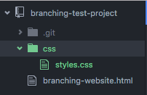
Next, let's tell our HTML document to use this new file for its CSS. We will include a link to the new CSS file in the tags of our branching-website.html file, like this:
branching-website.html
<!DOCTYPE html>
<html>
<head>
<link href="css/styles.css" rel="stylesheet" type="text/css">
<title> Branching Practice Site </title>
</head>
<body>
<h1> Branching </h1>
<h2> A website to practice branching with Git. </h2>
<p> This page has been created in order to practice branching with Git and GitHub. By creating branches, we can work on different versions of the same code in the same repository simultaneously! </p>
</body>
</html>
Let's add these new changes to our Git repository:
$ git add .
And commit them to the history of our project:
$ git commit -m "Create stylesheet, link in head of website."
Next, we'll add a basic CSS rule to our stylesheet:
css/styles.css
h1 {
color: blue;
}
If we open _branching-website.html_ file in our browser, we should see that the text in the <h1> tags is blue:
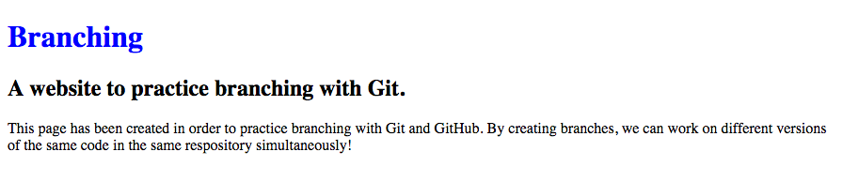
Let's add and commit this new CSS rule to our project:
$ git add css/styles.css
$ git commit -m "Add CSS rule to make H1 headers blue."
If we run $ git log we will see we now have 3 commits:
$ git log
commit 982b0f21463be34d909c45dd67778d6ffe3d7668
Author: Albert Einstein <einstein@email.com>
Date: Mon Jul 17 12:06:35 2017 -0700
Add CSS rule to make H1 headers blue.
commit 8e36f8bfd58643487565c5a4fbcb5250fed0808b
Author: Albert Einstein <einstein@email.com>
Date: Mon Jul 17 12:04:27 2017 -0700
Create stylesheet, link in head of website.
commit eb1774eee69d3e8fa1d74790dc9c64d70d1e9ec2
Author: Albert Einstein <einstein@email.com>
Date: Mon Jul 17 11:49:54 2017 -0700
Add initial HTML file with explanation of branching practice site.
Now that our basic website is set up, we can use it to learn about branching in the next section. Nice work!

Viewing a Project's Branches
Everything we've done thus far should be review. Now, let's explore the new concept at hand: branching. First we'll run the following command:
$ git branch
The $ git branch command displays what branches are currently in our project. It also denotes which branch we're currently viewing with an asterisk *. After we execute this command, we should see this:
* master
This informs us that there is only one branch: master. And, we know we're currently located in that branch because there is an asterisk next to it. Remember, master is the default branch. If we do not create any branches, or move between any branches, we will be on master.

Creating a New Branch
Let's pretend we're unsure how to style our site. We want to test a couple different stylistic approaches, and see which looks best. To do this, we'll create several versions of our project with branches. We'll implement different styles in each branch.
We can create a new branch by running the git branch command and including the name of the new branch after it, like this:
$ git branch blue_theme
This creates a new branch named blue_theme. Branch names should be short and meaningful, and describe the reason for the branch. In our case, this branch will contain styles that use the color blue throughout.
(Note that there are only two exceptions to these naming rules: The master branch will always be named master, and GitHub pages requires branches be named gh-pages in order to publish them using the GitHub pages tool.)

Navigating Between Branches
If we run $ git branch again, we can see our project now contains two branches:
$ git branch
blue_theme
* master
Notice the asterisk is still next to master. We created a new blue_theme branch, but we're still located on master. We can switch branches like this:
$ git checkout blue_theme
The $ git checkout command navigates to the specified branch. We can run $ git branch again to confirm we've successfully entered the blue_theme branch:
$ git branch
* blue_theme
master
The asterisk is now next to blue_theme, so we know we've successfully navigated to that branch. Now, let's look at our project in Atom. Despite being located in our new branch, everything should look the exact same.
When you create a branch, the new branch is "branched off" from the branch you are located in when the command to create a new branch is executed. This means the new branch will contain all code and commits from the branch it was branched off from. In our case, since we were located in master when we created blue_theme , blue_theme contains all code and commits that master contained at the time of the new branch's creation.
We can confirm this by running $ git log. We should see our new branch contains the same commits we made on master:
$ git log
commit 982b0f21463be34d909c45dd67778d6ffe3d7668
Author: Albert Einstein <einstein@email.com>
Date: Mon Jul 17 12:06:35 2017 -0700
Add CSS rule to make H1 headers blue.
commit 8e36f8bfd58643487565c5a4fbcb5250fed0808b
Author: Albert Einstein <einstein@email.com>
Date: Mon Jul 17 12:04:27 2017 -0700
Create stylesheet, link in head of website.
commit eb1774eee69d3e8fa1d74790dc9c64d70d1e9ec2
Author: Albert Einstein <einstein@email.com>
Date: Mon Jul 17 11:49:54 2017 -070
Add initial HTML file with explanation of branching practice site.

Working on a Branch
We now have a separate, isolated version of our project to experiment with. We can safely test code in blue_theme without risking the integrity of code in master. We can change, add, and commit whatever we'd like in blue_theme and master will remain completely unaffected. Let's add more CSS to the styles.css stylesheet:
styles.css
h1 {
color: blue;
text-align: center;
}
h2 {
font-style: italic;
text-align: center;
color: teal;
}
p {
color: gray;
}
body {
background-color: skyblue;
}
If we refresh our page in the browser, we can see these new styles:
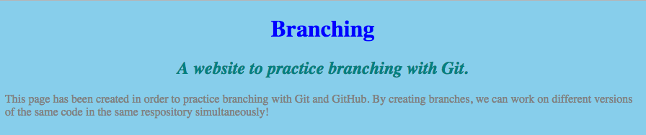
As always, we'll add these changes to our Git repository and commit them:
$ git add css/styles.css
$ git commit -m "Add styles to h1, h2, p, and body to fit blue theme."

Separation of Commits Between Branches
Let's run $ git log again to see a summary of our commits:
$ git log
commit 268363ae7b81a7ee91540d93f82e3f9285c575dd
Author: Albert Einstein <einstein@email.com>
Date: Mon Jul 17 12:24:38 2017 -0700
Add styles to h1, h2, p, and body to fit blue theme.
commit 982b0f21463be34d909c45dd67778d6ffe3d7668
Author: Albert Einstein <einstein@email.com>
Date: Mon Jul 17 12:06:35 2017 -0700
Add CSS rule to make H1 headers blue.
commit 8e36f8bfd58643487565c5a4fbcb5250fed0808b
Author: Albert Einstein <einstein@email.com>
Date: Mon Jul 17 12:04:27 2017 -0700
Create stylesheet, link in head of website.
commit eb1774eee69d3e8fa1d74790dc9c64d70d1e9ec2
Author: Albert Einstein <einstein@email.com>
Date: Mon Jul 17 11:49:54 2017 -0700
Add initial HTML file with explanation of branching practice site.
The blue_theme branch now contains the commits it inherited from master, and the new commit we've just made. Before we continue, let's return to our master branch for a moment using the git checkoutcommand:
$ git checkout master
As always, we can double-check we're on master by running $ git branch and confirming that master has an asterisk next to it:
$ git branch
blue_theme
* master
Great. Now, let's look at the commits on our master branch again:
$ git log
commit 982b0f21463be34d909c45dd67778d6ffe3d7668
Author: Albert Einstein <einstein@email.com>
Date: Mon Jul 17 12:06:35 2017 -0700
Add CSS rule to make H1 headers blue.
commit 8e36f8bfd58643487565c5a4fbcb5250fed0808b
Author: Albert Einstein <einstein@email.com>
Date: Mon Jul 17 12:04:27 2017 -0700
Create stylesheet, link in head of website.
commit eb1774eee69d3e8fa1d74790dc9c64d70d1e9ec2
Author: Albert Einstein <einstein@email.com>
Date: Mon Jul 17 11:49:54 2017 -0700
Add initial HTML file with explanation of branching practice site.
Notice that the new commit we just made on blue_theme is not present in master! Our blue_theme branch's most recent commit reads "Add styles to h1, h2, p, and body to fit blue theme." Whereas master's most recent commit reads "Add CSS rule to make H1 headers blue." And if we refresh our page in the browser again, we can see our blue styles are no longer present:
Also, if you view the styles.css stylesheet in Atom, you'll notice that the CSS rules we just added are gone! Don't worry; this is entirely normal. Because we switched branches, the version of the project we're seeing in Atom is different. The master branch does not have the same CSS rules as the blue_theme branch.
Remember, when we create a branch the new branch will inherit all commits from the branch it is branched off from. That is, the branch we are located in when we create the new branch. However, when we make new commits on our new branch, they remain on that branch. The organization of our current commits between branches look something like this:
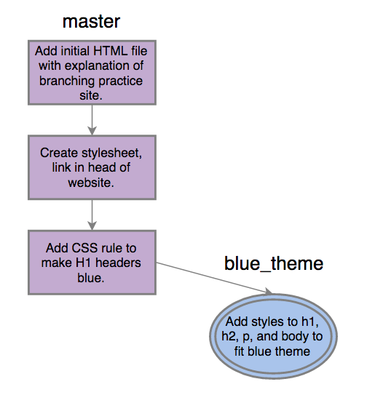
We can see our first three commits on master. When we branched off of master to create blue_theme, it inherited all of master's commits. However, when we made subsequent commits in blue_theme they remained exclusive to blue_theme and were not shared with master.

Working with Multiple Branches
Let's create another branch with a different set of CSS styles for our site. Remember, you may branch off from any existing branch. The new branch will contain all code and commits from whatever branch you were located within when the new branch was created.

Creating a New Branch
Let's branch from master again. We'll run $ git branch and confirm we're located in master:
$ git branch
blue_theme
* master
Then, we'll create another new branch named red_theme, like this:
$ git branch red_theme
We'll run $ git branch again to confirm our new branch has been created:
$ git branch
blue_theme
* master
red_theme

Navigating Between Branches
Next, we'll switch to our new red_theme branch using the git checkout command:
$ git checkout red_theme
Switched to branch 'red_theme'
We can run $ git branch to confirm we've successfully navigated into the red_theme branch:
$ git branch
blue_theme
master
* red_theme
And, if we run $ git log we can see red_theme has inherited all commits from master, as expected:
$ git log
commit 982b0f21463be34d909c45dd67778d6ffe3d7668
Author: Albert Einstein <einstein@email.com>
Date: Mon Jul 17 12:06:35 2017 -0700
Add CSS rule to make H1 headers blue.
commit 8e36f8bfd58643487565c5a4fbcb5250fed0808b
Author: Albert Einstein <einstein@email.com>
Date: Mon Jul 17 12:04:27 2017 -0700
Create stylesheet, link in head of website.
commit eb1774eee69d3e8fa1d74790dc9c64d70d1e9ec2
Author: Albert Einstein <einstein@email.com>
Date: Mon Jul 17 11:49:54 2017 -0700
Add initial HTML file with explanation of branching practice site.

Working on a Branch
Our styles.css file in Atom should currently look like this:
styles.css
h1 {
color: blue;
}
Again, notice that it does not contain the CSS we just committed in the blue_theme branch. The new red_theme branch was branched off of master. Therefore, it contains all of master's commits and code. It does not contain the code we committed on the blue_theme branch, only the master branch. Let's add styles to this branch's version of the styles.css file now:
styles.css
h1 {
color: darkred;
text-align: center;
}
h2 {
font-style: italic;
text-align: center;
color: red;
}
p {
color: crimson;
}
body {
background-color: salmon;
}
If we refresh our page in the browser, we can see our new CSS at work:
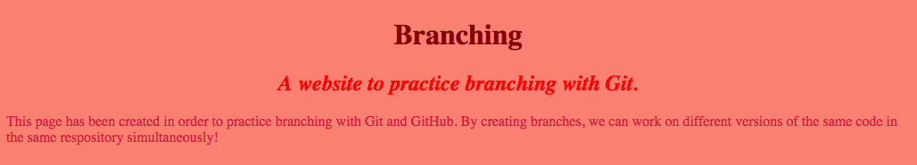
We'll add these changes to our Git repository, and commit:
$ git add css/styles.css
$ git commit -m "Add styles to h1, h2, p, and body to fit red theme."
As always, we can run $ git log to see a summary of our commits:
$ git log
commit 5f2d9510cdc76736c7c5cf7e5d56264cd405fcd1
Author: Albert Einstein <einstein@email.com>
Date: Mon Jul 17 12:51:11 2017 -0700
Add styles to h1, h2, p, and body to fit red theme.
commit 982b0f21463be34d909c45dd67778d6ffe3d7668
Author: Albert Einstein <einstein@email.com>
Date: Mon Jul 17 12:06:35 2017 -0700
Add CSS rule to make H1 headers blue.
commit 8e36f8bfd58643487565c5a4fbcb5250fed0808b
Author: Albert Einstein <einstein@email.com>
Date: Mon Jul 17 12:04:27 2017 -0700
Create stylesheet, link in head of website.
commit eb1774eee69d3e8fa1d74790dc9c64d70d1e9ec2
Author: Albert Einstein <einstein@email.com>
Date: Mon Jul 17 11:49:54 2017 -0700
Add initial HTML file with explanation of branching practice site.
We now have the commits that came along with the new branch when we branched from master, and the new commit we've just made on the red_theme branch. Our organization of commits between branches currently looks like this:
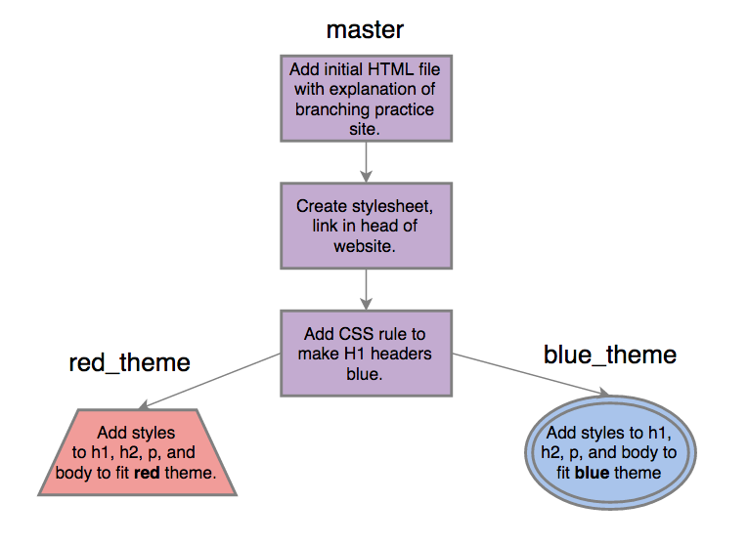
Now, let's say we want to improve the styles in red_theme even further by changing the site's text. We'll include the following additional CSS rules in styles.css:
styles.css
h1 {
color: darkred;
}
h2 {
font-style: italic;
color: red;
}
p {
color: crimson;
}
body {
background-color: salmon;
font-family: sans-serif;
text-align: center;
}
Here, we denote that everything located in the <body> tags should have sans-serif style font that is center-aligned. Because we're now styling everything in <body> tags we can remove text-align: center; from the existing h1 and h2 CSS rules.
The <h1> and <h2> tags exist within the <body> tags, so this rule will automatically apply to them too. We can save our changes and refresh the site to see our new styles:
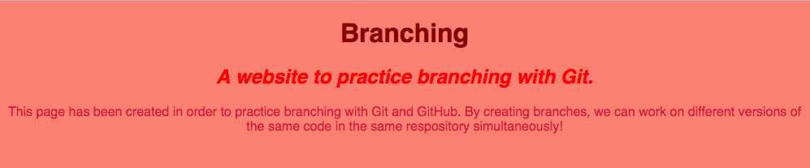
Again, we'll add these changes to our Git repository:
$ git add css/styles.css
And commit them with a descriptive message:
$ git commit -m "Make all font sans-serif style."
Let's run $ git log. We can see that in addition to the 3 commits inherited from master, the red_theme branch also has 2 of its own commits:
$ git log
commit d5bae6406669988e154608ce990e08fed51e9cb3
Author: Albert Einstein <einstein@email.com>
Date: Mon Jul 17 13:00:42 2017 -0700
Make all font sans-serif style.
commit 5f2d9510cdc76736c7c5cf7e5d56264cd405fcd1
Author: Albert Einstein <einstein@email.com>
Date: Mon Jul 17 12:51:11 2017 -0700
Add styles to h1, h2, p, and body to fit red theme.
commit 982b0f21463be34d909c45dd67778d6ffe3d7668
Author: Albert Einstein <einstein@email.com>
Date: Mon Jul 17 12:06:35 2017 -0700
Add CSS rule to make H1 headers blue.
commit 8e36f8bfd58643487565c5a4fbcb5250fed0808b
Author: Albert Einstein <einstein@email.com>
Date: Mon Jul 17 12:04:27 2017 -0700
Create stylesheet, link in head of website.
The commits across all branches of the project currently look like this:
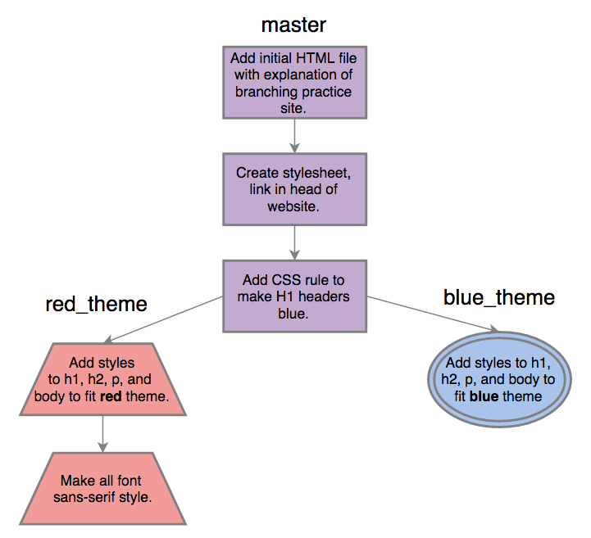

Benefits of Branching
Are you beginning to see how branching can be beneficial? It allows us to experiment with code and ensure it works correctly before saving it to our "final draft" master branch. When developers integrate new features into projects, they commonly do so in a branch. This allows them to make a copy of the entire project, experiment with new code, and confirm it does what it is supposed to before saving it into the final version.
This prevents bugs or issues from affecting the project. If the new code a developer adds or breaks anything, it won't cause issues on master, only on that isolated branch. This allows developers room to iron out any issues with code before integrating it into the final version of the project.
When code is fine-tuned and tested in the branch, and we know it works, we can add it to master. This process is called merging, and we'll explore it in detail in the next lesson as we continue to work with this example project.

Wednesday: Git Merging
In the last lesson we explored creating and managing multiple branches in a single Git repository. As we learned, branches allow us to create multiple copies of our code. These copies may be used to experiment with implementing new code, without putting the "final version" or master branch at risk of bugs or errors.
Additionally, branches can be used to simply try out different options before deciding which should end up in the final iteration of the project; like we did in the previous lesson with different sets of CSS styles.
However, once we confirm the code located in a feature branch works, and that we want to include it in the final version of our project, we need to integrate this code into the master branch that represents our final product. The act of incorporating code from multiple branches together is called merging. In this lesson, we'll walk through merging branches together in our example project.

Merging Branches
Let's say we've decided to use the CSS we wrote in the red_theme branch in the final version of our project. Since the master branch represents the final product, we'll need to merge the red_theme branch with master.
To merge two branches you must first navigate to the branch you'd like to introduce new code into. In our case, this is the master branch, because we'd like to integrate the CSS we created in red_theme into master.
Let's run $ git branch to see where we are currently located:
$ git branch
blue_theme
master
* red_theme
If you followed along with the previous lesson exactly, you should still be located in red_theme. Let's navigate into master using $ git checkout:
$ git checkout master
Switched to branch 'master'
Then, we'll run $ git branch again to confirm we've successfully navigated to master:
$ git branch
blue_theme
* master
red_theme
We can use the $ git merge command to bring the contents and commits of an outside branch into our current branch. In our case, we'll bring the commits from red_theme into the master branch we are currently located in. We'll run the following command:
$ git merge red_theme
This should result in something that looks like this:
Updating 982b0f2..d5bae64
Fast-forward
css/styles.css | 17 ++++++++++++++++-
1 file changed, 16 insertions(+), 1 deletion(-)
Now, let's run $ git log to view our commit history:
$ git log
commit d5bae6406669988e154608ce990e08fed51e9cb3
Author: Albert Einstien <einstein@email.com>
Date: Mon Jul 17 13:00:42 2017 -0700
Make all font sans-serif style.
commit 5f2d9510cdc76736c7c5cf7e5d56264cd405fcd1
Author: Albert Einstien <einstein@email.com>
Date: Mon Jul 17 12:51:11 2017 -0700
Add styles to h1, h2, p, and body to fit red theme.
commit 982b0f21463be34d909c45dd67778d6ffe3d7668
Author: Albert Einstien <einstein@email.com>
Date: Mon Jul 17 12:06:35 2017 -0700
Add CSS rule to make H1 headers blue.
commit 8e36f8bfd58643487565c5a4fbcb5250fed0808b
Author: Albert Einstien <einstein@email.com>
Date: Mon Jul 17 12:04:27 2017 -0700
Create stylesheet, link in head of website.
Notice that the two most recent commits from red_theme are now part of the commit history here in master. This is because we merged red_theme into master. This means all code and commits from red_theme have been incorporated into master, too.
The commit structure of our project across all branches currently looks like this:

Notice that merging red_theme with master has brought all commits previously exclusive to red_theme here in master. Also, notice that the red_theme commits don't instantly disappear when we merge them into master. They still exist in the red_theme branch.

Deleting Branches
After successfully merging a branch (always confirm all of the branch's commits are present), you may delete it if you do not plan on using it further. This is safe to do because all commits red_theme once contained are now present in master. So, we don't risk losing any work.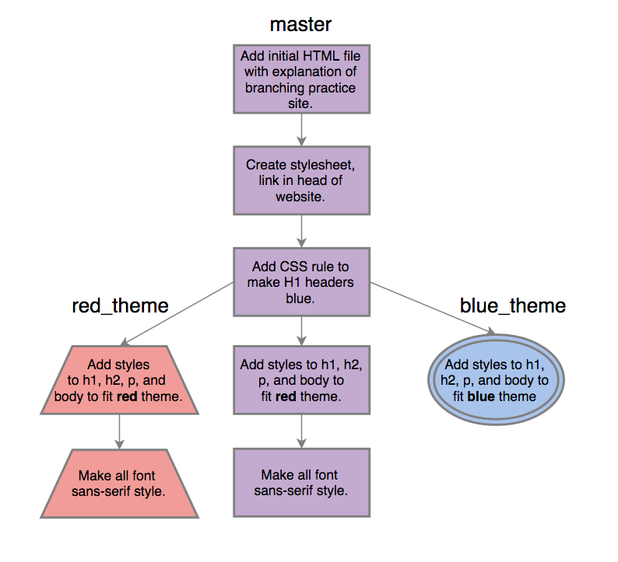
We can delete a branch using the $ git branch -D command, like this:
$ git branch -D red_theme
Deleted branch red_theme (was d5bae64).
We can run $ git branch and see red_theme has been removed from the repository entirely:
$ git branch
blue_theme
* master
And, since we opted to integrate the styles in red_theme instead of blue_theme, we no longer need the blue_theme branch either. We'll delete it at this time, too:
$ git branch -D blue_theme
Deleted branch blue_theme (was 268363a).
Know that merging doesn't always go quite this smoothly, unfortunately. If multiple branches contain edits to the same lines of code, Git won't know which edit should supersede which, and requires the developer to manually intervene (this primarily occurs when branches are working on the same code simultaneously, and both attempt to merge with master). This is known as a merge conflict.
However, we shouldn't encounter any merge conflicts quite yet. For now, simply make sure you're familiar with the general concepts of branching and merging, and able to create branches for use with GitHub Pages. We'll explore merge conflicts, what they look like, and how to resolve them later on.
As you can see, merging and branching in Git is a powerful, complex feature. However, don't feel overwhelmed if you don't yet have a handle on everything we've covered in these past two lessons. Feel free to refer back to this content whenever necessary. Soon enough, branching and merging will become second nature!

Wednesday: Practice: Branching and Merging
Goal: Now that you have spent some time learning about branching and merging, let’s practice! The goal of this exercise is to work on branching and merging along with your new CSS skills.

Warm Up
- What is the benefit of branching?
- How do we create a new branch of a project?
- Why would we want to merge back into master?

Code

Resort Website
You are hired by an investor to create a website for a private island resort that they are building.
Your website should have:
- A main home page
- Pages for:
  - accommodations
  - activities
  - travel arrangements
  - contact information
  - pictures, etc.
The investor doesn't know exactly what style they want for the website, so they have asked you to use your best judgement and provide them with at least two options for styling so they can make their decision later.
Make a branch for each style and when you are done, call a teacher over so that the "investor" can see their options and decide which style they would prefer. Once the "investor" (your TM) has made their selection, merge that branch into master.
Make sure you have been making commits throughout building this project and make a gh-pagesbranch to display it on GitHub Pages. And don't forget your README!

Further Exploration
If you and your partner finish all activities for the day with time to spare, make a website for your favorite restaurant. Include a page to display the menu, a page with contact information and hours, and a homepage describing the cuisine, or restaurant's history. Add styles using CSS, and publish the site on GitHub Pages.

hursday: Styling with Classes
Yesterday, we learned how to style elements of the page. Unfortunately, we had no way of targeting specific parts of the page. So if we wanted one <h2> to be green, all <h2> elements on the page would need to be green. In this lesson, we will learn some HTML code that allows us to label HTML elements so that we can style specific parts of the page any way we'd like.
Let's create a new page with some paragraphs about my favorite animal, the giraffe. These will be regular paragraphs with an introductory summary at the top of the page.
index.html
<!DOCTYPE html>
<html>
<head>
<link href="css/styles.css" rel="stylesheet" type="text/css">
<title>Giraffes!</title>
</head>
<body>
<h1>Giraffes</h1>
<h2>It's time to learn about the mysterious giraffe!</h2>
<p>This is an introduction. Lorem ipsum dolor sit amet, consectetur adipisicing elit, sed do eiusmod tempor incididunt ut labore et dolore magna aliqua.</p>
<p>At first glance, giraffes are pretty magical creatures. Ut enim ad minim veniam, quis nostrud exercitation ullamco laboris nisi ut aliquip ex ea commodo consequat. Duis aute irure dolor in reprehenderit in voluptate velit esse cillum dolore eu fugiat nulla pariatur. Excepteur sint occaecat cupidatat non proident, sunt in culpa qui officia deserunt mollit anim id est laborum.Sed ut perspiciatis unde omnis iste natus error sit voluptatem accusantium doloremque laudantium, totam rem aperiam, eaque ipsa quae ab illo inventore veritatis et quasi architecto beatae vitae dicta sunt explicabo. Nemo enim ipsam voluptatem quia voluptas sit aspernatur aut odit aut fugit, sed quia consequuntur magni dolores eos qui ratione voluptatem sequi nesciunt.</p>
<p>At vero eos et accusamus et iusto odio dignissimos ducimus qui blanditiis praesentium voluptatum deleniti atque corrupti quos dolores et quas molestias excepturi sint occaecati cupiditate non provident, similique sunt in culpa qui officia deserunt mollitia animi, id est laborum et dolorum fuga. Et harum quidem rerum facilis est et expedita distinctio. Nam libero tempore, cum soluta nobis est eligendi optio cumque nihil impedit quo minus id quod maxime placeat facere possimus, omnis voluptas assumenda est, omnis dolor repellendus. Temporibus autem quibusdam et aut officiis debitis aut rerum necessitatibus saepe eveniet ut et voluptates repudiandae sint et molestiae non recusandae. Itaque earum rerum hic tenetur a sapiente delectus, ut aut reiciendis voluptatibus maiores alias consequatur aut perferendis doloribus asperiores repellat.</p>
<p>Lorem ipsum dolor sit amet, consectetur adipisicing elit, sed do eiusmod tempor incididunt ut labore et dolore magna aliqua. Ut enim ad minim veniam, quis nostrud exercitation ullamco laboris nisi ut aliquip ex ea commodo consequat. Duis aute irure dolor in reprehenderit in voluptate velit esse cillum dolore eu fugiat nulla pariatur. Excepteur sint occaecat cupidatat non proident, sunt in culpa qui officia deserunt mollit anim id est laborum.</p>
<h3>About the Author</h3>
<p>Here's some information about the author. Nam libero tempore, cum soluta nobis est eligendi optio cumque nihil impedit quo minus id quod maxime placeat facere possimus, omnis voluptas assumenda est, omnis dolor repellendus.</p>
</body>
</html>
As a note here, the text used to fill these paragraphs is known as lorem ipsum. It looks like Latin, but the words are jumbled and don't really have any meaning. Lorem ipsum text is often used as a placeholder for text when doing website design; you can search online for "lorem ipsum" and find many varieties and websites where you can copy the text.
This page is nice, but let's the introductory paragraph to look more like an introduction - I want the text to be italicized.
To label the introductory paragraph, first we add a class to the <p> tag:
<p class="intro">This is an introduction. Lorem ipsum dolor sit amet, consectetur adipisicing elit, sed do eiusmod tempor incididunt ut labore et dolore magna aliqua.</p>
Now we can add a rule to our stylesheet that targets this paragraph by using a class selector. Here's what that looks like:
css/styles.css
.intro {
font-style: italic;
}
When we refresh the page, we see that the paragraph with the class intro is italicized. In the rule, the HTML element with a class of intro was targeted with the class selector intro. All class selectors begin with a period: ..
We can also apply a class to multiple tags. Let's say we want our info about the author to be red. Let's add some classes:
index.html
<h3 class="author">About the author</h3>
<p class="author">Here's some information about the author. Nam libero tempore, cum soluta nobis est eligendi optio cumque nihil impedit quo minus id quod maxime placeat facere possimus, omnis voluptas assumenda est, omnis dolor repellendus.</p>
And here's the CSS rule:
styles.css
.author {
color: red;
}
The class selector targets all elements of a particular class. It's possible, however, for multiple elements on a web page to share a specific styling, but for one of those elements to differ slightly.
For example, I want both the header and the paragraph with the class author to be red, but I want the paragraph text to be a smaller font than the rest of the paragraphs on the page. But what happens when I do this?
styles.css
.author {
color: red;
font-size: 12px;
}
The paragraph text size is smaller, but so is the header. Instead, we can target the paragraph with the author class like this:
styles.css
.author {
color: red;
}
p.author {
font-size: 12px;
}
This code uses a new selector: p.author. What's the difference between the .author and the p.author selectors?
The .author selector targets all elements with the class author. The p.author selector targets only <p>elements with the class author. This type of selector allows you to be even more specific with your styling.

Thursday: Practice - Styling with Classes
Goal: Practice using classes to style large portions of our webpages, and applying classes to multiple HTML tags.

Warm up
Discuss the following with your partner:
- What's the difference between styling using classes and styling elements directly?
- What does a class selector in the stylesheet look like?

Code
Follow along with the lesson to create the page about giraffes that uses classes to style various sections of the page.

Travel Agency
Create a webpage for the Happy Trails Travel Agency. The page should have text, images, and links. Feature various travel destinations and get creative!
Add a class named tropical for tropical destinations. Give the headers the color #f7325e and the text the color #7dc410. Use the fantasy font family.
Add a class named popular for the most popular destination. Add some styling to distinguish it from the other destination listings. What happens when a popular destination is also a tropical destination? How can you make sure that the styles you want to see on the page are displayed?

News Article
Create a new project folder containing news-article.html containing a fake news article. Use lorem ipsum text with <p> tags to give you paragraphs. Add a few images to illustrate the news, as well as headers to divide the page into sections.
Let the first section on the page be the introduction. Give it a subheader (<h2>), a paragraph or two, and an image. Each element in this section should have the class introduction. Create styles for all of the elements in this section to set them apart from the rest of the content on the page. Use the selectors h2.introduction, p.introduction, and img.introduction for the styles.

Favorite Things: More Practice
Get some more practice styling with classes by adding classes and class selectors for your CSS rules to your copy of favorite-things.html.

hursday: Class vs. ID
Before we go on, let's talk about the difference between assigning a class to an HTML tag and assigning an id to an HTML tag. For the remainder of this section you can ignore IDs and continue using classes, but a brief explanation is in order, as you are likely to find references to IDs when reading resources online.
Both classes and IDs can be targeted by CSS rules (classes with a . and IDs with a # symbol). For example, both paragraph tags below are styled the same, though one is referenced by class and the other by ID.
index.html
<html>
<head>
<link href="styles.css" rel="stylesheet" type="text/css" media="all">
<title>Some Exciting Red Text</title>
</head>
<body>
<p class="line1">This text will appear red.</p>
<p id="line2">This text will also be red. </p>
</body>
</html>
styles.css
.line1 {
color: red;
}
#line2 {
color: red;
}

The important difference is that IDs are unique, while classes are not unique. We can use the same class on multiple elements, while IDs must be unique to a single element on the page. IDs may appear to work even when duplicated on the same page, but duplicate IDs can lead to inconsistent behavior and hard-to-find bugs.
If in doubt, use a class.

Thursday: Divs and Spans
Classes are useful for applying styles to parts of a page, but sometimes you have a style that you want to apply to an entire part of your page, and adding a class to every tag can be unwieldy. It can also result in an HTML file that is difficult to read. Here's a new page I made about wildcats.
wildcats.html
<!DOCTYPE html>
<html>
<head>
<link href="css/styles.css" rel="stylesheet" type="text/css" media="all">
<title>Wildcats</title>
</head>
<body>
<h1>Wildcats</h1>
<p>I'm going to teach you all about wildcats. First, the important stuff:</p>
<h2 class="important">Types of wildcats</h2>
<p class="important">There are many types of wildcats. Lorem ipsum dolor sit amet, consectetur adipisicing elit, sed do eiusmod tempor incididunt ut labore et dolore magna aliqua. Ut enim ad minim veniam, quis nostrud exercitation ullamco laboris nisi ut aliquip ex ea commodo consequat.</p>
<p class="important">Here are some types of wildcats:</p>
<ul class="important">
<li>Lion</li>
<li>Tiger</li>
<li>Jaguar</li>
</ul>
<h2 class="important">More important stuff</h2>
<p class="important">You should also know this about wildcats. Ut enim ad minim veniam, quis nostrud exercitation ullamco laboris nisi ut aliquip ex ea commodo consequat. Duis aute irure dolor in reprehenderit in voluptate velit esse cillum dolore eu fugiat nulla pariatur.</p>
<p>Now, for some less important stuff about wildcats.</p>
<h2 class="unimportant">Wildcats communicate with over a dozen different types of sound.</h2>
<p class="unimportant">Duis aute irure dolor in reprehenderit in voluptate velit esse cillum dolore eu fugiat nulla pariatur. Eaque ipsa quae ab illo inventore veritatis et quasi architecto beatae vitae dicta sunt explicabo.</p>
<h2 class="unimportant">Wildcats make great dance partners</h2>
<p class="unimportant">It's a little-known fact that wildcats are actually great dance partners. Sed ut perspiciatis unde omnis iste natus error sit voluptatem accusantium doloremque laudantium, totam rem aperiam, eaque ipsa quae ab illo inventore veritatis et quasi architecto beatae vitae dicta sunt explicabo.</p>
</body>
</html>
See all of the classes we had to add to make certain elements important and unimportant? We can simplify this using the new tag, <div>:
wildcats.html
<!DOCTYPE html>
<html>
<head>
<link href="css/styles.css" rel="stylesheet" type="text/css" media="all">
<title>Wildcats</title>
</head>
<body>
<h1>Wildcats</h1>
<p>I'm going to teach you all about wildcats. First, the important stuff:</p>
<div class="important">
<h2>Types of wildcats</h2>
<p>There are many types of wildcats. Lorem ipsum dolor sit amet, consectetur adipisicing elit, sed do eiusmod tempor incididunt ut labore et dolore magna aliqua. Ut enim ad minim veniam, quis nostrud exercitation ullamco laboris nisi ut aliquip ex ea commodo consequat.</p>
<p>Here are some types of wildcats:</p>
<ul>
<li>Lion</li>
<li>Tiger</li>
<li>Jaguar</li>
</ul>
<h2>Other important stuff</h2>
<p>Here is some other really important stuff about wildcats. Ut enim ad minim veniam, quis nostrud exercitation ullamco laboris nisi ut aliquip ex ea commodo consequat. Duis aute irure dolor in reprehenderit in voluptate velit esse cillum dolore eu fugiat nulla pariatur.</p>
</div>
<p>Now, for some less important stuff about wildcats.</p>
<div class="unimportant">
<h2>Wildcats communicate with over a dozen different types of sound.</h2>
<p>Duis aute irure dolor in reprehenderit in voluptate velit esse cillum dolore eu fugiat nulla pariatur. Eaque ipsa quae ab illo inventore veritatis et quasi architecto beatae vitae dicta sunt explicabo.</p>
<h2>Wildcats make great dance partners</h2>
<p>It's a little-known fact that wildcats are actually great dance partners. Sed ut perspiciatis unde omnis iste natus error sit voluptatem accusantium doloremque laudantium, totam rem aperiam, eaque ipsa quae ab illo inventore veritatis et quasi architecto beatae vitae dicta sunt explicabo.</p>
</div>
</body>
</html>
Then we can style entire sections of the page using the selectors .important and .unimportant in our CSS:
css/styles.css
.important {
color: red;
}
.unimportant {
color: blue;
}
The <div> tag does not actually do anything on its own - it simply defines a section of a page. It acts as a container to separate the content of a page, so that when used with CSS, styles can be applied to an entire section. Remember, good code is code that is easy to change: When we use <div>s and want to change a class name, we only need to change one <div> instead of all of the elements inside of it.
There is a similar tag for inline elements called <span>:
wildcats.html
<p>Wildcats are versatile creatures that can live in <span class="important">many different climates</span>. They can live in <span class="cat-climate">the jungle</span>, <span class="cat-climate">the mountains</span>, and even <span class="cat-climate">the desert</span>. Look carefully, and you may find one in <span class="important">your own backyard</span>!
Now let's add some style for our new class, .cat-climate:
styles.css
.important {
color: red;
}
.unimportant {
color: blue;
}
.cat-climate {
background-color: yellow;
}

The same class can be used to apply the same styles to both spans and divs, as we did with .important.

Thursday: Practice: Divs and Spans
Goal: Practice adding divs and spans to pages.

Warm Up
Discuss the following with your partner:
- What is the difference between divs and spans?
- If I wanted to highlight a specific phrase in a paragraph, would it be better to use a div or a span?
- If I wanted to highlight a group of paragraphs, would it be better to use a div or a span?

Code
Follow along with the lesson to create the webpage about wildcats, dividing the page into important and unimportant sections. Then, choose one (or several) of the following to practice using divs and spans to style the page.

Travel Agency
Pull up the page you made for Happy Trails Travel Agency and rewrite it to remove the tropical and popularclasses from the elements themselves, and use divs instead.

News Article
Rewrite the news article webpage by removing the introduction class from the elements themselves and create a div with the introduction class to hold the elements.

Resume
Create a webpage to display your resume. Use divs and spans to style sections of the page to list your work experience, skills, education, contact info, and any other sections you'd like your resume to have.

hursday: Floats
All the pages we've made so far have been laid out pretty simply - top to bottom for block elements, and left to right for inline elements. But often we will want our pages to have more complexity, with columns or a sidebar, or text wrapping around an image. We can use floats to design these kinds of layouts.
Let's see what this looks like. Here's an example of text wrapping around an image:
index.html
<!DOCTYPE html>
<html>
<head>
<link href="css/styles.css" rel="stylesheet" type="text/css">
<title>Mangoes</title>
</head>
<body>
<img src="img/mango.jpg" alt="An image of a ripe mango.">
<p>Mangoes are one of the world's favorite fruits. Lorem ipsum dolor sit amet, consectetur adipisicing elit, sed do eiusmod tempor incididunt ut labore et dolore magna aliqua. Ut enim ad minim veniam, quis nostrud exercitation ullamco laboris nisi ut aliquip ex ea commodo consequat. Duis aute irure dolor in reprehenderit in voluptate velit esse cillum dolore eu fugiat nulla pariatur. Excepteur sint occaecat cupidatat non proident, sunt in culpa qui officia deserunt mollit anim id est laborum. Ut enim ad minim veniam, quis nostrud exercitation ullamco laboris nisi ut aliquip ex ea commodo consequat. Duis aute irure dolor in reprehenderit in voluptate velit esse cillum dolore eu fugiat nulla pariatur.</p>
</body>
</html>
And here's the CSS rule:
css/styles.css
img {
float: left;
}
When we pull up the page, we can see that the image "floats" to the left, and the text wraps to the right of it. You can resize your browser window to see that when the area for the text exceeds the image size, the text flows underneath the image. If you'd like, you can also make the text float to the right by using float: right; instead.
Let's see how we can use floats to create a sidebar:
index.html
<!DOCTYPE html>
<html>
<head>
<link href="css/styles.css" rel="stylesheet" type="text/css">
<title>Mangoes</title>
</head>
<body>
<h1>All about mangoes</h1>
<div class="sidebar">
<h2>Eating mangoes</h2>
<p>Mangoes are delicious! Here are some ways to enjoy them:</p>
<ul>
<li>By themselves</li>
<li>Smoothies</li>
<li>Fruit salad</li>
<li>With coconut rice</li>
</ul>
</div>
<div class="main">
<p>Mangoes are one of the world's favorite fruits. Lorem ipsum dolor sit amet, consectetur adipisicing elit, sed do eiusmod tempor incididunt ut labore et dolore magna aliqua. Ut enim ad minim veniam, quis nostrud exercitation ullamco laboris nisi ut aliquip ex ea commodo consequat. Duis aute irure dolor in reprehenderit in voluptate velit esse cillum dolore eu fugiat nulla pariatur. Excepteur sint occaecat cupidatat non proident, sunt in culpa qui officia deserunt mollit anim id est laborum. Ut enim ad minim veniam, quis nostrud exercitation ullamco laboris nisi ut aliquip ex ea commodo consequat. Duis aute irure dolor in reprehenderit in voluptate velit esse cillum dolore eu fugiat nulla pariatur.</p>
</div>
</body>
</html>
Here's the CSS:
styles.css
.sidebar {
width: 30%;
float: right;
background-color: yellow;
}
Refresh the page, and now we have a yellow sidebar on the right of the page. Let's see one more example of floats and make some columns on the page:
index.html
<!DOCTYPE html>
<html>
<head>
<link href="css/styles.css" rel="stylesheet" type="text/css" media="all">
<title>Columns</title>
</head>
<body>
<h1>Let's see some columns!</h1>
<div class="column">
<p>Lorem ipsum dolor sit amet, consectetur adipisicing elit, sed do eiusmod tempor incididunt ut labore et dolore magna aliqua. Ut enim ad minim veniam, quis nostrud exercitation ullamco laboris nisi ut aliquip ex ea commodo consequat. Duis aute irure dolor in reprehenderit in voluptate velit esse cillum dolore eu fugiat nulla pariatur. Excepteur sint occaecat cupidatat non proident, sunt in culpa qui officia deserunt mollit anim id est laborum. Ut enim ad minim veniam, quis nostrud exercitation ullamco laboris nisi ut aliquip ex ea commodo consequat. Duis aute irure dolor in reprehenderit in voluptate velit esse cillum dolore eu fugiat nulla pariatur.</p>
</div>
<div class="column">
<p>Lorem ipsum dolor sit amet, consectetur adipisicing elit, sed do eiusmod tempor incididunt ut labore et dolore magna aliqua. Ut enim ad minim veniam, quis nostrud exercitation ullamco laboris nisi ut aliquip ex ea commodo consequat. Duis aute irure dolor in reprehenderit in voluptate velit esse cillum dolore eu fugiat nulla pariatur. Excepteur sint occaecat cupidatat non proident, sunt in culpa qui officia deserunt mollit anim id est laborum. Ut enim ad minim veniam, quis nostrud exercitation ullamco laboris nisi ut aliquip ex ea commodo consequat. Duis aute irure dolor in reprehenderit in voluptate velit esse cillum dolore eu fugiat nulla pariatur.</p>
</div>
<div class="column">
<p>Lorem ipsum dolor sit amet, consectetur adipisicing elit, sed do eiusmod tempor incididunt ut labore et dolore magna aliqua. Ut enim ad minim veniam, quis nostrud exercitation ullamco laboris nisi ut aliquip ex ea commodo consequat. Duis aute irure dolor in reprehenderit in voluptate velit esse cillum dolore eu fugiat nulla pariatur. Excepteur sint occaecat cupidatat non proident, sunt in culpa qui officia deserunt mollit anim id est laborum. Ut enim ad minim veniam, quis nostrud exercitation ullamco laboris nisi ut aliquip ex ea commodo consequat. Duis aute irure dolor in reprehenderit in voluptate velit esse cillum dolore eu fugiat nulla pariatur.</p>
</div>
</body>
</html>
With the CSS:
styles.css
.column {
width: 350px;
float: left;
}
Now we have columns! As you can see, floats are a useful way to lay out web pages.

hursday: Practice: Floats
Goal: Practice using floats to organize webpage layouts. Use concepts from the lesson on floats, such as wrapping text around an image, creating sidebars, and creating pages with multiple columns.

Warm Up
Discuss the following with your partner:
- What are some of the options available to us for using floats?
- What are we able to accomplish using floats?

Code
Follow along with the lesson and create the page about mangoes and pay attention to how floats are used to change the layout of the page.

Band Website
Create a website for your favorite band. Give the page a sidebar for upcoming shows. Create an "About the band" section and a section for images, and use floats to set the layout of the page.

Photographer Portfolio
Create a website for a photographer. Divide the page into columns that feature different categories of photography: For example, one for portraits, one for nature, and one for weddings.

Resume
Pull up your resume from the divs and spans practice, and use floats to divide the different sections into columns and rows. For example, the skills section can be broken into columns to save vertical space.

Thursday: Box Model
There's one more essential piece of HTML and CSS we need to cover: the box model. You can think of every element on a web page as a rectangular box that takes up space, and it's made of four parts: content, padding, border, and margin. This is easiest to see in a diagram:
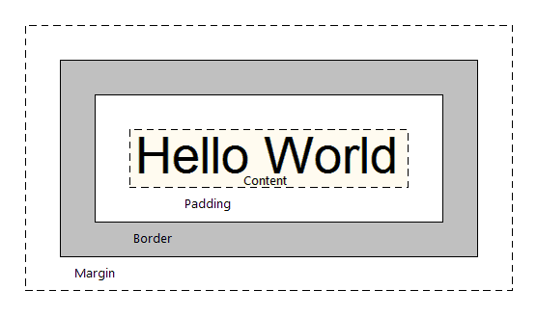
When you see height and width used in CSS, those values apply to the content.
Let's use some CSS to demonstrate the box model on a web page. Start with some unstyled text contained in a div:
index.html
<!DOCTYPE html>
<html>
<head>
<link href="css/styles.css" rel="stylesheet" type="text/css" media="all">
<title>Box model</title>
</head>
<body>
<div class="test-box">Lorem ipsum dolor sit amet, consectetur adipisicing elit, sed do eiusmod tempor incididunt ut labore et dolore magna aliqua. Ut enim ad minim veniam, quis nostrud exercitation ullamco laboris nisi ut aliquip ex ea commodo consequat. Duis aute irure dolor in reprehenderit in voluptate velit esse cillum dolore eu fugiat nulla pariatur. Excepteur sint occaecat cupidatat non proident, sunt in culpa qui officia deserunt mollit anim id est laborum. Ut enim ad minim veniam, quis nostrud exercitation ullamco laboris nisi ut aliquip ex ea commodo consequat. Duis aute irure dolor in reprehenderit in voluptate velit esse cillum dolore eu fugiat nulla pariatur.</div>
</body>
</html>
Let's add a border using CSS:
css/styles.css
.test-box {
border: 2px solid red;
}
We can actually give each side a different value if we'd like:
styles.css
.test-box {
border-left: 2px solid red;
border-right: 4px solid blue;
border-top: 6px solid orange;
border-bottom: 8px solid black;
}

For the sake of space, I'll keep the border uniform for the rest of these examples.
Now let's increase the space between the text and the border:
styles.css
.test-box {
border: 2px solid red;
padding: 6px;
}

Finally, let's make some room between the border and the elements around it (which are, in this simple case, just the edges of the page):
styles.css
.test-box {
border: 2px solid red;
padding: 6px;
margin: 20px;
}

Let's see what happens when we give the div a background color:
styles.css
.test-box {
border: 2px solid red;
padding: 6px;
margin: 20px;
background-color: yellow;
}

The color applies to the box content and the padding.
We can see the box model for an element in the DevTools Inspect panel. For this example, it looks something like this:
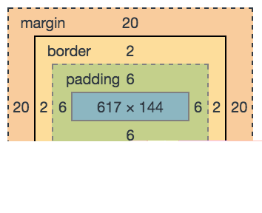
You'll run into the box model a lot when building web pages, so spend some time getting familiar with it.

Thursday: Practice: Box Model
Goal: Implement the box model in our code to organize and layout the page content.

Warm Up
- What is the difference between margin and padding?
- What are some benefits to using the box model?

Code
Follow along with the lesson on the box model and understand how its various properties affect the layout of elements on the page. After you have gone through the lesson, here are some exercises for you to practice using margins, borders, and padding. Choose one project to start - you are not expected to complete all of the exercises, but to understand the box model.

Band Website
- For the sidebar to your band's webpage, add a border and a bit of padding and margin. Give the sidebar a background color, if you haven't already.
- Add some padding around the images on your band's webpage.

Resume
Use the box model to further format sections of your resume. For example, give each section a border to separate different sections from each other.

Photography Portfolio
Use the box model to lay out the presentation of your photography portfolio from the Floats exercise. Give each photo a border, and give each column a different background color.

Thursday: Cascading and Inheritance
You may have noticed that, in earlier lessons, we defined a style for <ul>, and it was applied to the text that was inside of <li> tags. This is called inheritance: since the <li> tags are nested within the <ul>tags, the <li> tags inherit the styles given to the <ul>s.
On the other hand, when we applied a style to <p> tags on the same page as a <ul>, it was not applied to <ul>. <p> and <ul> are not nested within another, so their styles are applied independently.
We can use inheritance to change the font for the entire web page like this:
body {
font-family: sans-serif;
}
Since all of the other elements in the web page are nested within the <body> tag, all of the text for the page will be Sans Serif.
Let's see how we can use cascading to target specific child elements. For example, take this HTML:
index.html
<!DOCTYPE html>
<html>
<head>
<link href="css/styles.css" rel="stylesheet" type="text/css">
<title>Cats vs Dogs</title>
</head>
<body>
<h1>Cats vs Dogs: the Definitive Guide</h1>
<p>Welcome to the ultimate showdown between cats and dogs. May the best one win!</p>
<div class="cats">
<p>Here's why cats are great. Lorem ipsum dolor sit amet, consectetur adipisicing elit, sed do eiusmod tempor incididunt ut labore et dolore magna aliqua. Ut enim ad minim veniam, quis nostrud exercitation ullamco laboris nisi ut aliquip ex ea commodo consequat.</p>
<p>Find out more about cats <a href="http://www.example.com/cats.html">here</a>.</p>
</div>
<div class="dogs">
<p>Here's why dogs are great. Duis aute irure dolor in reprehenderit in voluptate velit esse cillum dolore eu fugiat nulla pariatur. Excepteur sint occaecat cupidatat non proident, sunt in culpa qui officia deserunt mollit anim id est laborum.</p>
<p>Find out more about dogs <a href="http://www.example.com/dogs.html">here</a>.</p>
</div>
<p>Who will win? You will be the judge.</p>
</body>
</html>
Say we want to color-code each paragraph so that we can tell which paragraphs are about cats and which ones are about dogs. Here is how we can style the paragraphs in each div differently:
css/styles.css
.cats p {
background-color: coral;
}
.dogs p {
background-color: steelblue;
}
These rules tell the page that all <p> tags nested within the cats class need the background color coral, and all <p> tags nested within the dogs class need the background color steelblue.
You can nest even further down:
styles.css
.cats p a {
font-weight: bold;
}
.dogs p a {
font-style: italic;
}
You can actually nest as far down as you like. A word of caution, however: anything more than 3 or 4 levels deep is usually a sign that you should re-evaluate what you are trying to accomplish with your CSS. Chances are, there's a much more efficient way to accomplish what you're attempting to do.
Now, consider the following rules:
styles.css
.dogs p a {
font-weight: bold;
}
a {
font-weight: normal;
}
When it comes to CSS rules, the more specific rule is applied. In this example, a link in a paragraph in an element with the dogs class will be bold, because the .dogs p a selector is more specific than the aselector. This is called specificity.
There's one more thing I'd like to cover about cascading: if two rules have the same specificity, the last one wins - in other words, the one that's the farthest down in the CSS file takes precedence. When more than one CSS file is linked in the page head, then again, the furthest one down takes precedence.
Occasionally, you'll run into HTML that looks like this:
<img style="float: left" src="cute-kitten.jpg">
Here, the style is embedded in the HTML using the style attribute: style="float: left". This is called an inline style, and it should be avoided at all costs! It defeats the purpose of CSS when you do this, because it means that now you can't reuse your styles and keep them in one place. This is not a common practice, but you still may run into it every once in awhile. The main takeaway here is that if you see an inline style, it takes precedence over what's defined in your CSS.
There are some additional rules about which style takes precedence in more complicated situations, but that's beyond the scope of what we're learning here.

Thursday: Practice: Cascading and Inheritance
Goal: Practice identifying HTML selectors using CSS, and understand various rules of cascading.

Warm Up
Discuss the following questions with your partner:
- Why is it a bad idea to use inline styling?
- What is meant by specificity? How is it related to cascading?

CSS Diner
CSS Diner is a game that will let you hone your chops at using CSS selectors. Click the link and proceed through the game with your partner, switching places at each level.
(Links to an external site.)
Links to an external site.

Code

Animal Shelter
Create a webpage for an animal shelter that features the animals available for adoption on the home page. Use divs and floats to give each animal its own profile section. Change the styles of the elements on the page using cascading.

Past Projects
Take a look at some of your past projects and try to find places where you could rewrite the page using cascading.

Thursday: Responsive Design and Media Queries
You may have noticed that some websites look a little different on your phone than they do in a browser window on your computer screen. Altering the appearance of a website depending on the device used to view it is an important feature of CSS that ensures a quality user experience on any device. It's essential to building modern websites. In this lesson, we'll learn about adapting a site for different screen sizes using media queries.
Building a site to change its appearance in response to the size of screen on which it is being viewed is known as responsive web design. The screen being used to view a site is often called a viewport. Before we begin, let's take a look at some examples of websites that use responsive design. Check out the following two websites to view some examples of responsive design. Each site contains the layouts of several different websites, and how their styles appear differently depending on the user's screen size.
- Responsive Design
(Links to an external site.)
Links to an external site.
- mediaqueri.es
(Links to an external site.)
Links to an external site.
But how do we make our own sites responsive? How does it know when to use styles meant for smaller viewports, and when to apply styles meant for larger ones?
In human terms, responsive design sounds something like, "I want my website to have a white background when viewed on a phone, but a green background when viewed from a computer monitor". To accomplish this, you need to give the computer instructions such as, "If the viewport size is larger than 768 pixels, use green for the background color. Otherwise, use white for the background color." To accomplish this, we can use CSS media queries. A media query is a block of CSS that is applied only when certain conditions about the user's viewport are true.
Let's walk through creating media queries together. This will allow us to both understand their construction, and see what they look like in action.
Create a project directory named media-query-practice. Inside, create an HTML file named media-query-site.html, and another directory named css. In the css directory create a file called styles.css.
To start, let's add some HTML to media-query-site.html:
<!DOCTYPE html>
<html>
<head>
<link href="css/styles.css" rel="stylesheet" type="text/css" media="all">
<title>Media Queries</title>
</head>
<body>
<h1>Media Queries</h1>
<div class="column">
<p>Lorem ipsum dolor sit amet, consectetur adipiscing elit. Nunc tincidunt vestibulum sollicitudin. Aliquam sit amet ultrices purus, quis pulvinar massa. Sed quis ligula dapibus, gravida lectus sit amet, euismod quam. Integer id nisi sem. Phasellus ac purus et nunc dignissim ultricies quis sed ligula. Proin efficitur nunc eget egestas iaculis. Proin posuere, enim in venenatis gravida, erat metus hendrerit tellus, sit amet sollicitudin magna mauris sit amet ex. In hac habitasse platea dictumst. Fusce porta suscipit felis vitae ornare. Duis fringilla, nunc vitae aliquam lacinia, metus urna tincidunt erat, ut laoreet leo mi ac nibh. </p>
</div>
<div class="column">
<p>In pretium eu sem quis dignissim. In commodo velit eu elit volutpat bibendum. Proin a orci pharetra, pharetra mauris et, tempor odio. Nullam semper magna sit amet augue pretium molestie. Quisque ullamcorper turpis a nisi consectetur, vel consectetur purus lobortis. Pellentesque tristique justo id faucibus rutrum. Donec mi lacus, molestie et posuere eget, lacinia sed turpis. Aenean id sem ligula. Cras venenatis commodo felis a tempor. Duis nec leo facilisis, condimentum odio dictum, rutrum lectus. Nullam vehicula elementum imperdiet.</p>
</div>
<div class="column">
<p>Nullam sit amet ante porttitor, vestibulum quam nec, tincidunt sem. Nulla ac diam in risus porta sollicitudin. Nam pellentesque diam nec arcu vehicula varius. Praesent id ornare magna. Aliquam congue nisl enim, id vulputate lacus faucibus non. Sed ac dignissim dui, quis porttitor augue. Donec velit erat, hendrerit ut tincidunt vel, placerat sit amet risus.</p>
</div>
</body>
</html>

Now, the fun part: let's add some media queries!
Media queries are located in CSS stylesheets. Because of the cascading in CSS, they should be located at the bottom of the file, to prevent other style rules from overriding them.
The basic skeleton of a media query looks like this:
@media () {
}

There are three parts to this block of code:
- @media tells the browser that this is a media query
- The parentheses will contain the conditions of when to apply CSS
- The curly braces will contain the CSS rule to be applied when the conditions contained in the parenthesis are true

Media Type
Media queries will often include something called a media type, which refers to the type of device the user is viewing a site with. We have the following options to choose from:
- all: Suitable for all devices.
- print: Intended for viewing a site in "print preview" mode. For instance, if we had a website with a dark-colored background that users may want to print, we could use a print media query that removes the dark-colored background for print media types. This would both make our website's information more legible in a printed format, and save our users printer ink.
- screen: Intended primarily for color computer screens.
- speech: Intended for screen readers that assist users with impaired vision.
If you do not explicitly specify a type, the media query will default to all.
Here's how to add the media type to a query:
@media screen () {
}

By specifying the screen media type, we're instructing our site to only apply any CSS in this media query to the site if a user is viewing it through a screen.

Media Features
To tell a media query the conditions of when to apply CSS, we include something called a media feature. Media features are specific properties and details about the manner the user is viewing content. The most commonly-used media features are:
- height: Describes the height of the viewport, in pixels. This media feature can also have a min or max prefix added onto it. That is, we can say max-height to specify the maximum height to which a media query's CSS should apply. Or min-height to define a minimum height.
- width: Describes the width of the viewport, in pixels. Like height, it may also have a min or max prefix added onto it.
- orientation: Indicates whether the viewport is landscape (wider than it is tall) or portrait(taller than it is wide).
While not required for this course, you can learn about the additional, less common features in the MDN Documentation on Media Queries.
(Links to an external site.)
Links to an external site.
Let's use the width media feature in our media query. We'll also include the min prefix, in order to specify a minimum width:
@media screen and (min-width: 480px) {
}

We've done a few things here:
- First, we specified that this CSS rule will apply to the screen media type.
- Then we added the word and between our screen media type, and the parenthesis containing our new media feature. The and keyword is used for combining media features with media types, as well as combining multiple media features together.
- Then, we included min-width: 480px in the parenthesis.
  - width is our media feature.
  - The min prefix specifies that the CSS we will eventually include in this media query should only be applied to viewports with a minimum width of 480 pixels.
  - 480px simply refers to size (in pixels) we'd like to define as the maximum. When defining pixel sizes in CSS, the px suffix is required.

Breakpoints
This rule means the CSS we will eventually include in this media query will only be applied when the user's viewport is wider than the minimum width of 480 pixels. This is known as a breakpoint.
A breakpoint is the point at which a media query's condition becomes true. For instance, because our media query has a min-width of 480px, it will apply its styles only when the viewport is 480 pixels wide or greater. 480px is therefore the breakpoint, because it is the point at which the query will be "activated".
For some standard device breakpoints, check out this reference at CSS Tricks.
(Links to an external site.)
Links to an external site.

Mobile-First Design
Let's focus on the min and max prefix for a bit here. What's the difference? Why does it matter which one we use?
When we use min-width, then the design changes when the width is larger than 480 pixels. Using max-widthmeans that the design changes when the width gets smaller than 480 pixels. min-width will make the page display faster on smaller devices, and is a good idea because smaller devices usually have less power to display a website. This approach to designing a website is called mobile first design, because it means designing for mobile screens before designing for desktop or other devices. When in doubt, take the mobile first approach.

CSS Rules
All right, we have our setup ready to make some media queries. Let's start writing some CSS! We will include CSS within the curly braces, and the CSS is exactly like the CSS we've been using so far. The only difference is that the CSS rule will only be applied when the media query conditions are met.
@media screen and (min-width: 480px) {
body {
background-color: black;
color: white;
}
}

We're saying that when the user is viewing our page from a screen, and the page width is larger than 480 pixels, then the background color will be black and the text color will be white. Any smaller than that, and only the default styles will be applied. Try it out!

We can add multiple media queries to address a variety of viewport sizes and media types. Let's add another media query to our site:
@media screen and (min-width: 480px) {
body {
background-color: black;
color: white;
}
}
@media screen and (min-width: 768px) {
body {
background-color: yellowgreen;
}
}

If you refresh the page, you can see that if the width is between 480 and 767 pixels, the background color is black, when the width is 768 pixels or larger, the background color changes to yellow-green. Notice that the text color remains white after the background turns yellow-green, even though we don't specify text color in the second CSS rule. This is because he viewport is still greater than 480 pixels wide, and we didn't say anything about text color in the second CSS rule. Unless we override the color property with a new rule, it will remain white.

Viewport Ranges
We can also specify both minimum and maximum values for a media query. This can be useful if we don't want to worry about certain styles applying to multiple media queries.
We could add a max-width to our media query like this:
@media screen and (min-width: 480px) and (max-width: 767px) {
body {
background-color: black;
color: white;
}
}
@media screen and (min-width: 768px) {
body {
background-color: yellowgreen;
}
}

To specify the viewport range, we added a second and between the two sets of parentheses. Now when we refresh the page, we see that the text color is white only for the first media query, and changes back to black when the screen width is greater than 767 pixels.

More CSS in Media Queries
Let's look at another example of how we can use media queries to change our webpage's display. Often, sites will display text in a single column for easy reading on mobile phones or smaller devices, but display the text in columns on larger devices (see this example from mediaqueri.es).
(Links to an external site.)
Links to an external site.
We've styled text into columns in a previous lesson on floats. Where do you think we need to put the CSS for displaying our text as columns at only larger screen sizes?
Here's the CSS:
@media screen and (min-width: 480px) and (max-width: 767px) {
body {
background-color: black;
color: white;
}
}
@media screen and (min-width: 768px) {
body {
background-color: yellowgreen;
}
.column {
width: 220px;
float: left;
padding: 15px;
}
}

Our new rule will float any element with the column class to the left, and make its width 220 pixels, but only for screens larger than 768 pixels. Check it out! Our text is displayed in a single column by default:
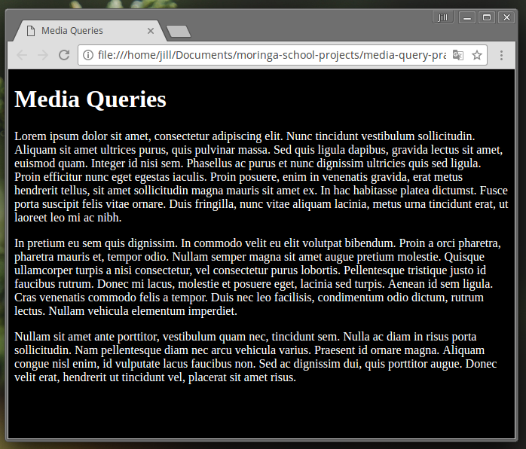
But at larger screen sizes, we have columns:
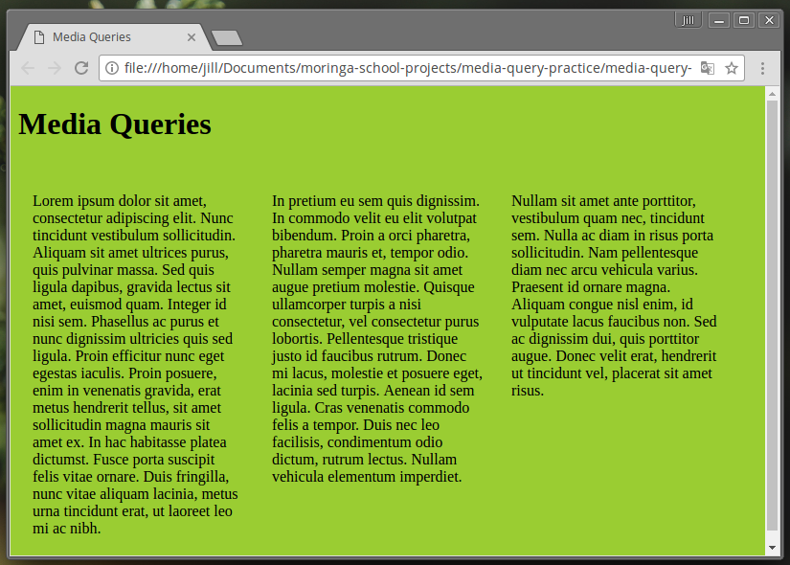
As you can see, media queries are a powerful tool in web design! We have the ability to tailor our user's experience of the webpage depending on how they view it. As more individuals are accessing web content through handheld devices and tablets, it's a good idea to be aware of responsive design and how we can use it to give the user the highest quality experience.
As you create websites and applications throughout this course, begin implementing media queries to ensure your content looks great on all devices.

